How everyone hope you all are doing well and enjoying the learning of Course. In this reading, you will learn how to calculate the mean, mode, median, and standard deviation of a set of data. The mean, median and mode of a data set are collectively known as measures of central tendency as these three measures focus on where the data is centered or clustered.

We use statistics such as the mean, median and mode to obtain information about a population from our sample set of observed values.

**Mean**

The mean (or average) of a set of data values is the sum of all of the data values divided by the number of data values.  That is:

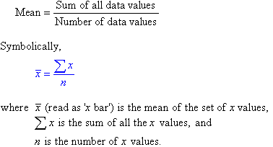

The marks of seven students in a mathematics test with a maximum possible mark of 20 are given below:

     15     13     18     16     14     17     12

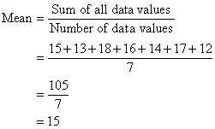

Symbolically, we can set out the solution as follows:

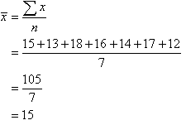

So, the mean mark is 15.

**Median**

The median of a set of data values is the middle value of the data set when it has been arranged in ascending order.  That is, from the smallest value to the highest value.

The marks of nine students in a geography test that had a maximum possible mark of 50 are given below:

     47     35     37     32     38     39     36     34     35

Arrange the data values in order from the lowest value to the highest value:

     32     34     35     35     36     37     38     39     47

The fifth data value, 36, is the middle value in this arrangement.



If the number of values in the data set is even, then the **median** is the average of the two middle values.

Note:

* Half of the values in the data set lie below the median and half lie above the median.
* The median is the most commonly quoted figure used to measure property prices.  The use of the median avoids the problem of the mean property price which is affected by a few expensive properties that are not representative of the general property market.

**Mode**

The mode of a set of data values is the value(s) that occurs most often.

The mode has applications in printing.  For example, it is important to print more of the most popular books; because printing different books in equal numbers would cause a shortage of some books and an oversupply of others.

Likewise, the mode has applications in manufacturing.  For example, it is important to manufacture more of the most popular shoes; because manufacturing different shoes in equal numbers would cause a shortage of some shoes and an oversupply of others.

Find the mode of the following data set:

     48     44     48     45     42     49     48

The mode is **48** since it occurs most often.

Note:

* It is possible for a set of data values to have more than one mode.
* If there are two data values that occur most frequently, we say that the set of data values is bimodal.
* If there is no data value or data values that occur most frequently, we say that the set of data values has no mode.

To analyse data using the mean, median and mode, we need to use the most appropriate measure of central tendency. The following points should be remembered:

* The mean is useful for predicting future results when there are no extreme values in the data set. However, the impact of extreme values on the mean may be important and should be considered. E.g. The impact of a stock market crash on average investment returns.
* The median may be more useful than the mean when there are extreme values in the data set as it is not affected by extreme values.
* The mode is useful when the most common item, characteristic, or value of a data set is required.